Intermag Digest Preparation Instructions

Erai Takahashi¹, Stan Laurel², and Oliver N. Hardy², Fellow, IEEE

¹Institute of Magnetics, World Leading University, Monbetsu, 094-0011, Japan, erai@wlu.co.jp
²Department of Physics, University of Life, Los Angeles, CA 90230, USA, stan@uol.edu

This template and instructions will help you to prepare a two-page digest for the Intermag Conference. The general layout is almost identical to the standard template of the IEEE Transactions on Magnetics, except that Intermag digests are limited to two pages. You should use this document as a template for preparing your contributions. You may also use the Latex template provided on the Intermag website. Accepted digests will be published on IEEE Xplore. Please carefully follow the instructions contained in this document in order to maintain digest legibility and uniformity.

Index Terms—About four key words or phrases in alphabetical order, separated by commas. For a list of suggested keywords, go to https://www.ieee.org/content/dam/ieee-org/ieee/web/org/pubs/ieee-taxonomy.pdf.

T

Introduction
his document is a template for Microsoft Word. The electronic version can be downloaded from the conference website.

General Layout of the Two-Page Digest
Please prepare the digest on Letter size paper (8.5 in x 11 in = 21.6 cm x27.9 cm) or A4 paper (21.0 cm x 29.7 cm). The digest should be prepared in double-column format, except for the title and the abstract, as shown above. The total text height should be 9.6 in (24.4 cm). The total width should be 7.2 in (18.3 cm) with a separation of 0.2 in (0.5 cm) between the columns. Please provide a top margin of 0.7 in (1.8 cm) and a left margin of 0.65 in (1.65 cm). Paragraphs follow the indented paragraph format with left and right justification. Use 0.36 cm for paragraph indentation. Do not leave space between the paragraphs. The line spacing within each paragraph is ‘Multiple’ at ‘1.05’ (rather than ‘Single’).
Please number section headings with Roman numerals and center them in the column. The spacing before and after the section headings should be 12 pt and 4 pt, respectively. Please number the subheadings with alphabetical letters. The spacing before and after the subheadings is 6 pt and 3 pt, respectively. The indentation for subheadings is 0.1 in (0.25 cm).

Type and Size of Fonts
Please use the Times New Roman typeface and follow the type sizes specified in Table I as closely as possible. If you use nonstandard fonts for special symbols, please embed them in the PDF (export option). To embed fonts in the PDF you must tick the ‘PDF/A Compliant’ box in the ‘Options’ menu. This menu is displayed by clicking on the ‘Options’ button in the dialog ‘Publish as PDF or XPS’.
TABLE I
Types Sizes For Digests
Item | Type Size  (points) | Appearance
Title | 17 | Bold
Author’s Name | 11 | Regular
Author’s Affiliations, mailing address, and E-mail | 10 | Regular
Abstract | 9 | Bold
Section Titles | 10 | Small capitals, centered in column, Roman numerals
Subheadings | 10 | Italics, alphabetical numerals
Main Text | 10 | Regular
Subscripts and Superscripts in the Main Text | 8 | Regular
Equations | 10 | Regular
Figure Captions | 8 | Regular, centered in column, Arabic numerals
Table Captions | 8 | Small capitals, title case, centered in column, Roman numerals
Table Name/Description | 8 | Small capitals, title case, centered in column, Roman numerals
Table Text | 8 | Regular
Subscripts and Superscripts in Table Text | 6 | Regular
References | 8 | Regular
No vertical lines in table. Statements that serve as captions for the entire table do not need footnote letters. A longer description of the table would go here.

Useful Hints

Abbreviations and Acronyms
Define abbreviations and acronyms the first time they are used, even after they have been defined in the abstract. Commonly acceptable abbreviations such as IEEE, SI, MKS, ac, and dc do not have to be defined. Do not use abbreviations in the title unless they are unavoidable.

Figures and tables
Place figures and tables in the middle of columns. Figure captions should be left justified below the figures; table captions should be centered above the tables. Please use words rather than symbols to label the axes. As an example, write the quantity “Magnetization”, or “Magnetization, M”, not just “M”. Put units in parentheses. Do not label axes only with units. As in Fig. 1, for example, write “Magnetization (emu/cm³)” or “Magnetization (emu·cm⁻³)”, not just “emu/cm³”. Do not label axes with a ratio of quantities and units. For example, write “Temperature (K)”, not “Temperature/K”. Multipliers can be confusing. Write “Applied field (kOe)” or “Applied field (10³ Oe),” not “Applied field (Oe×1000)” because the readers would not know whether the right axis label in Fig. 1 meant 20000 Oe or 0.02 Oe.
Figure labels should be legible, approximately 8 to 12 point type when reduced to column width. Note that “Fig.” is abbreviated. There is a period after the figure number, followed by a space.
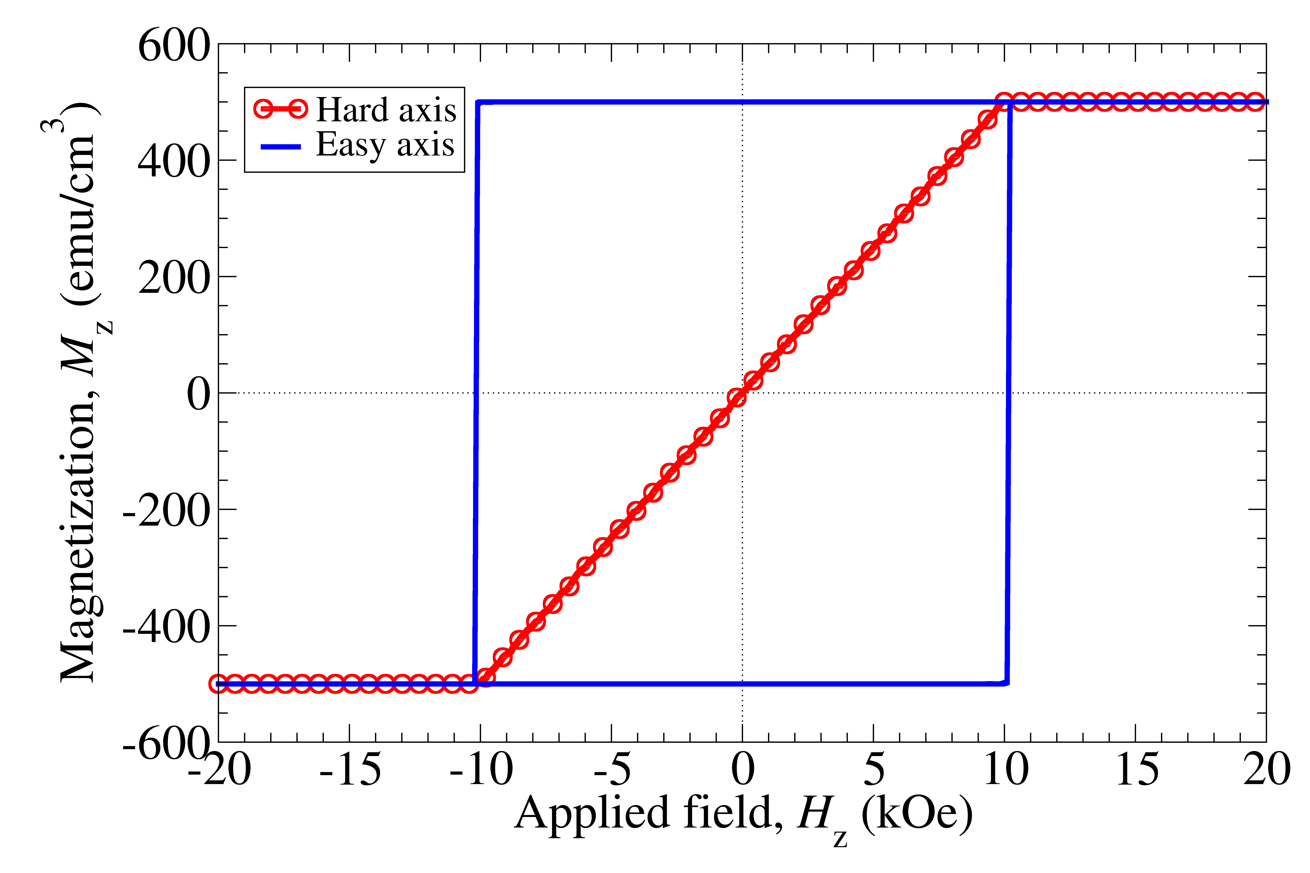
Fig. 1. Magnetization as a function of applied field.

Equations
Number equations consecutively with equation numbers in parentheses flush with the right margin, as in (1). To make your equation more compact, you may use the solidus (/), the exp function, or appropriate exponents. Use parentheses to avoid ambiguities in denominators. Punctuate equations when they are part of a sentence, as in
(1)
Be sure that the symbols in your equation have been defined before the equation appears or immediately following. Refer to “(1)”, not “Eq. (1)” or “equation (1)” except at the beginning of a sentence: “Equation (1) is…”. Please confine equations to one column width and break equations at appropriate algebraic symbols.

Units
Use either SI (MKS) or CGS as primary units. SI units are strongly recommended. Avoid combining SI and CGS units, such as current in Ampere and magnetic field in Oersted. If you must use mixed units, clearly state the units for each quantity in an equation.

Conclusion
A conclusion section is not required. Although a conclusion may review the main points of the paper, do not replicate the abstract in the conclusion. A conclusion might elaborate on the importance of the work or suggest applications and extensions.

References
Number citations consecutively in square brackets [1]. The sentence punctuation follows the brackets [2]. Multiple references [2], [3] are each numbered with separate brackets [2]-[3]. When citing a section in a book, please give the relevant page numbers [2]. In sentences, refer simply to the reference number, as in [3]. Do not use “Ref. [3]” or “reference [3]” except at the beginning of a sentence. Papers that have not been published should be cited as “unpublished” [4]. Papers that have been submitted for publication should be cited as “submitted for publication” [5]. Papers that have been accepted for publication but not yet specified for an issue should be cited as “to be published” [6]. Please give affiliations and address for private communications [7]. Use a space after authors’ initials. Capitalize only the first word in a paper title, except for proper nouns and element symbols.
References should be used to place your work in context. Authors should not excessively cite their own prior publications. The editors of Magnetics Society journals and conference proceedings are opposed to all forms of bibliometric (impact factor) manipulation. Do not include gratuitous or irrelevant references to articles.

Language
The use of grammar and spelling checkers is strongly recommended. It is also suggested that you have the digest proofread by a native English-speaking colleague if your native language is not English.

References
- G. Eason, B. Noble, and I. N. Sneddon, “On certain integrals of Lipschitz-Hankel type involving products of Bessel functions,” Phil. Trans. Roy. Soc. London, vol. A247, pp. 529-551, Apr. 1955.
- J. Clerk Maxwell, A Treatise on Electricity and Magnetism, 3rd ed., vol. 2. Oxford: Clarendon, 1892, pp. 68-73.
- I. S. Jacobs and C. P. Bean, “Fine particles, thin films and exchange anisotropy,” in Magnetism, vol. III, G. T. Rado and H. Suhl, Eds. New York: Academic, 1963, pp. 271-350.
- T. L. Gilbert, Formulation, Foundations and Applications of the Phenomenological Theory of Ferromagnetism, Ph.D. dissertation, Illinois Inst. Tech., Chicago, IL, 1956, unpublished.
- S. O. Demokritov, “Brillouin light scattering spectroscopy of magnetic nanostructures,” IEEE Trans. Magn.,submitted for publication.
- E.H. Miller, “A note on reflector arrays,” IEEE Trans. Antennas Propagat., to be published.
- C.J. Kaufman, Rocky Mountain Research Laboratories, Boulder, CO, private communication, 2014.

